Checklist

1. Web scraping

<https://levelup.gitconnected.com/a-guide-to-storing-scraped-data-with-python-a275d849463e>

Data Wrangling Python:

1. **Finding duplicates**

In this section you will identify duplicate values in the dataset.

Find how many duplicate rows exist in the dataFrame.

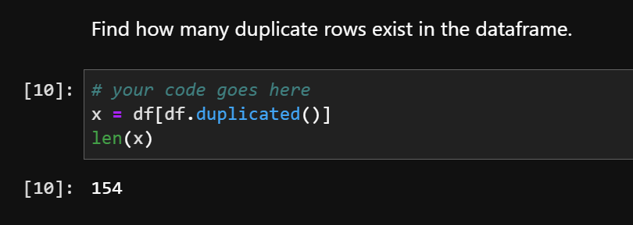

## Removing duplicates

Remove the duplicate rows from the dataframe.

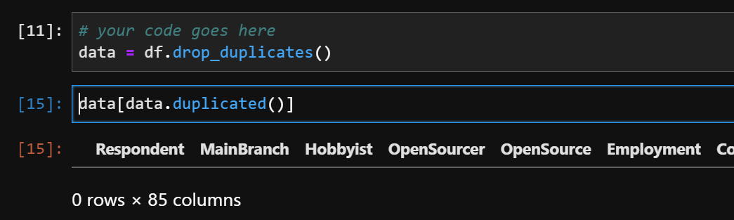

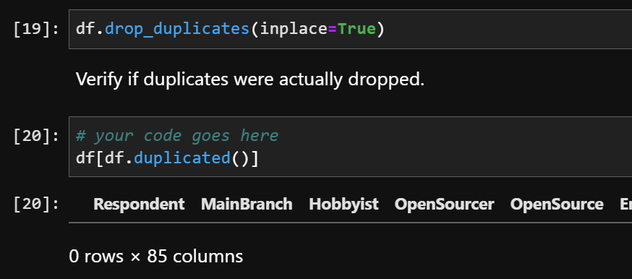

## Finding Missing values

Find the missing values for all columns.

Please refer to this if you want to learn more.

<https://datatofish.com/count-nan-pandas-dataframe/>